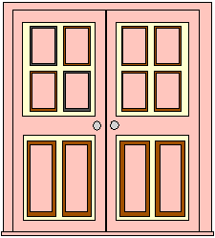

Closing the Back Door of the Church
What can we put at the back door?
What Do We Do
at the Front Door?


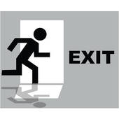
1. Each church needs a trained conflict resolution team
2. We must accept that it is often appropriate for people to leave
3. We trust our process of discipling
1. We need plans for assimilation
2. There must be a strategy for identifying a person’s passionate gift area and a plan to help them put it to use
3. The Fellowship piece must extend beyond the church walls and become a community
4. Celebrate, celebrate, and celebrate
How do we handle the Closet Door?
1. We must have a clear understanding and communication of who we are and what we are about
2. We owe it to the people to fully and completely orient them to our church culture
3. We owe it to the people to disciple them into a living relationship grounded first in Jesus, then in the Church fellowship
4. It will only last as long and go as deep as our strategy

